***Writing a Data Exploration Report***

**ID:**

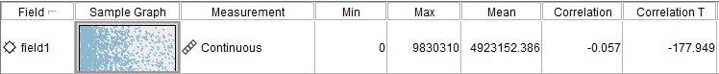

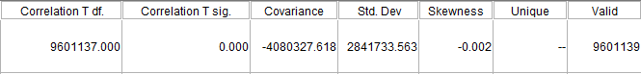

The Product ID has all the 9830310 Unique and Valid Records

**Graph for ID:**

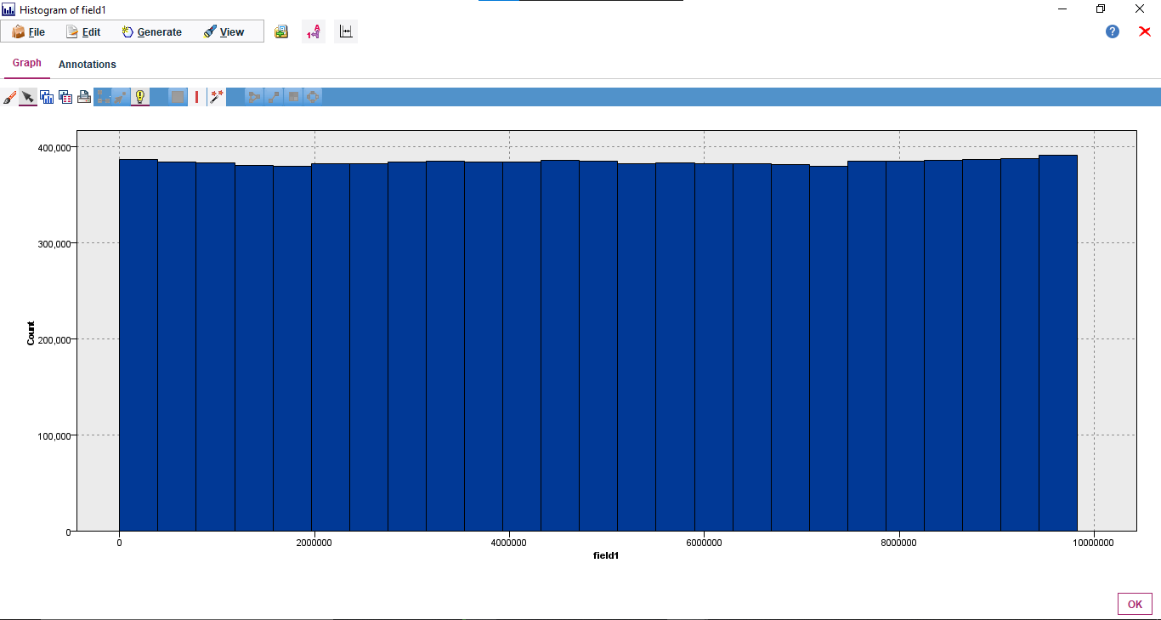

It shows the counts of the ID within a particular Range.

**Duration:**

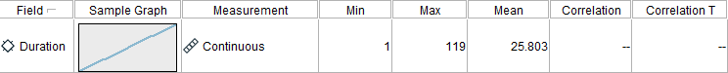

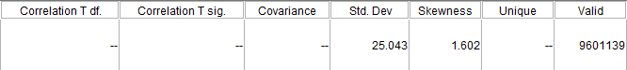

From the Output of this Audit Node, we can infer that:

* + 1. Values range from has 1-119
    2. It has the skewness = 1.602
    3. Mean = 25.803
    4. Standard Deviation = 25.043 shows that the data is distributed within the range of +- 25.043 from the Mean
    5. It has 9601139 Valid Values

**Graph for Duration:**

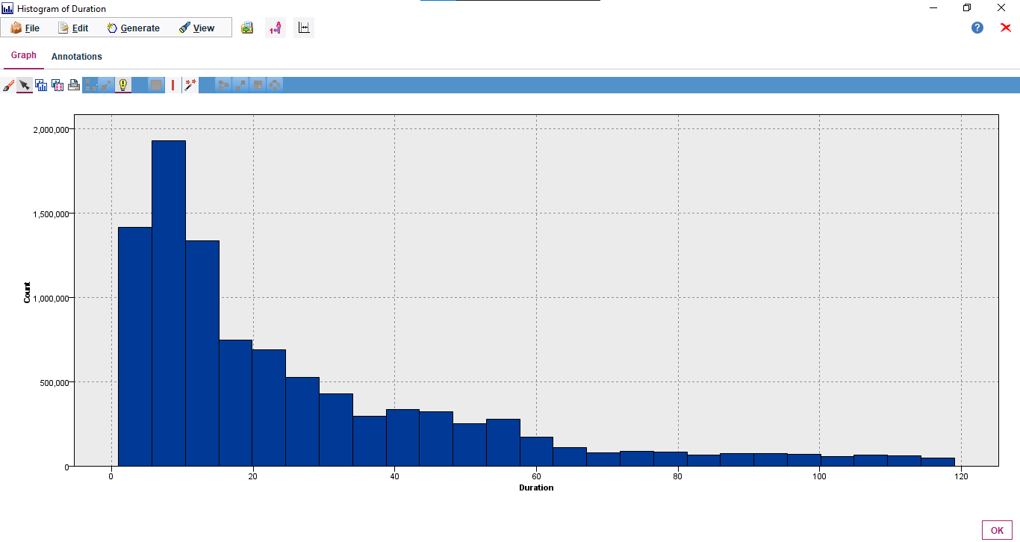

It shows the counts of the duration within a particular Range.

**Distance:**

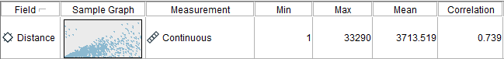



From the Output of this Audit Node, we can infer that:

* + 1. Values range from has 1 - 33290
    2. It has the skewness = 2.508
    3. Mean = 3713.519
    4. Standard Deviation = 3956.611 shows that the data is distributed within the range of +- 3956.611 from the Mean
    5. It has 9601139 Valid Values

**Graph for Distance:**

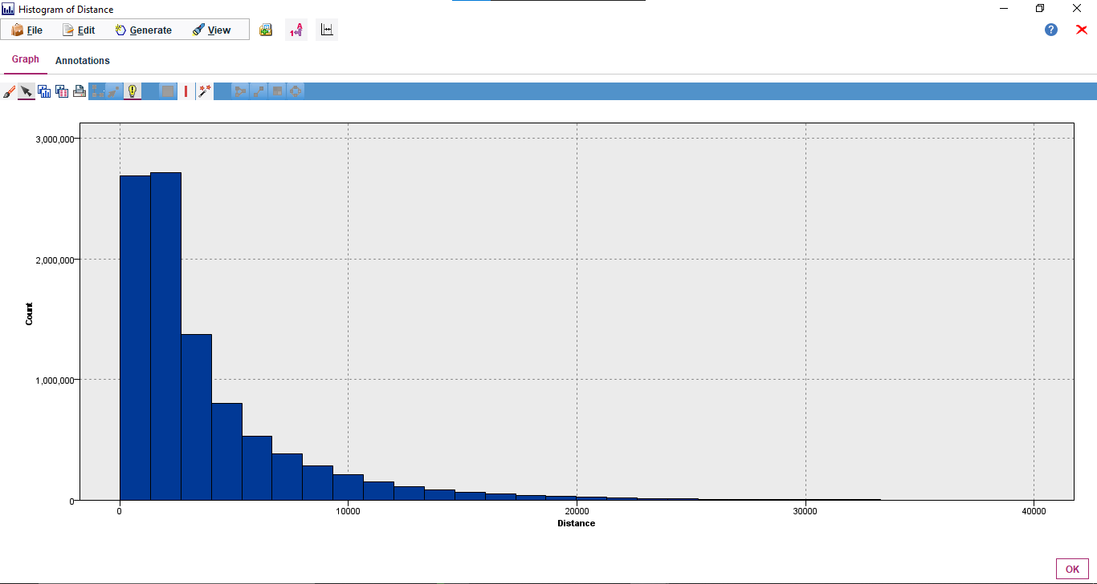

It shows the counts of the distance within a particular Range.

**PLong:**

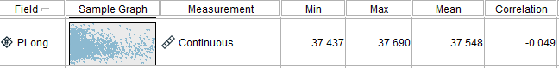



From the Output of this Audit Node, we can infer that:

* + 1. Values range from has 37.437 – 37.690
    2. It has the skewness = 0.408
    3. Mean = 37.548
    4. Standard Deviation = 0.044 shows that the data is distributed within the range of +- 0.044 from the Mean
    5. It has 9601139 Valid Values

**Graph for PLong:**

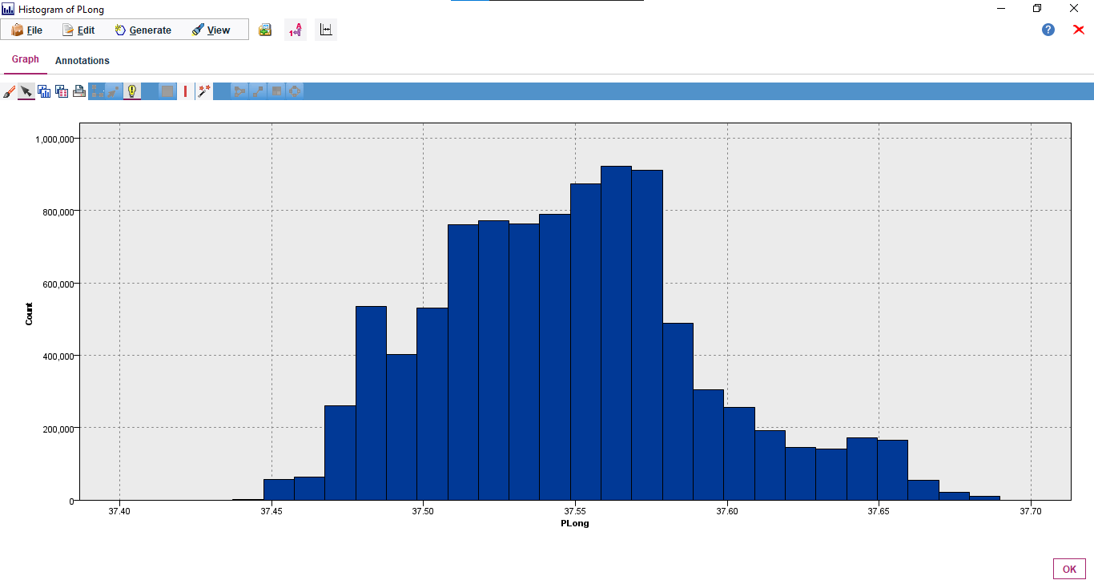

It shows the counts of the PLong within a particular Range.

**PLatd:**

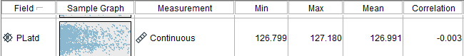

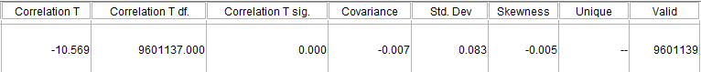

From the Output of this Audit Node, we can infer that:

* + 1. Values range from has 126.799 – 127.180
    2. It has the skewness = -0.005
    3. Mean = 126.991
    4. Standard Deviation = 0.083 shows that the data is distributed within the range of +- 0.083 from the Mean
    5. It has 9601139 Valid Values

**Graph for PLatd:**

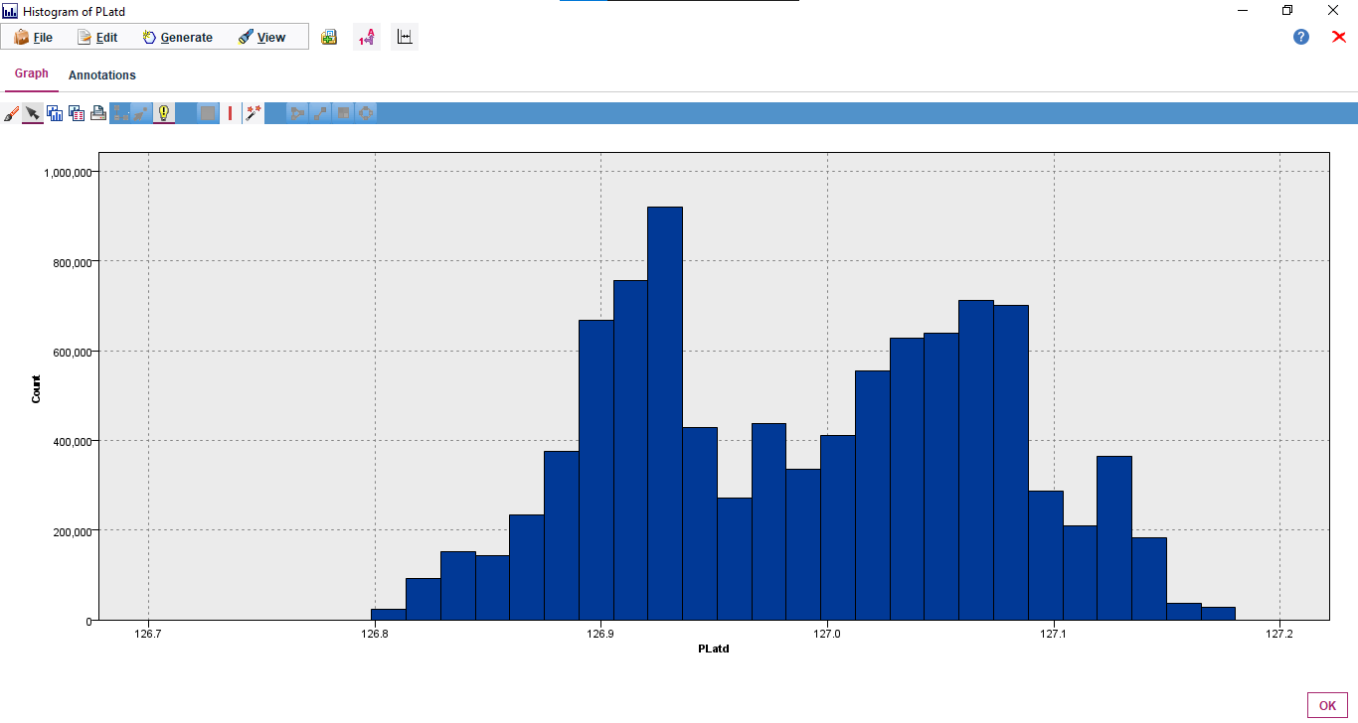

It shows the counts of the PLatd within a particular Range.

**Dlong:**

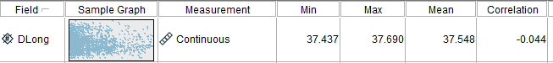



From the Output of this Audit Node, we can infer that:

* + 1. Values range from has 37.437 – 37.690
    2. It has the skewness = 0.412
    3. Mean = 37.548
    4. Standard Deviation = 0.044 shows that the data is distributed within the range of +- 0.044 from the Mean
    5. It has 9601139 Valid Values

**Graph for DLong:**

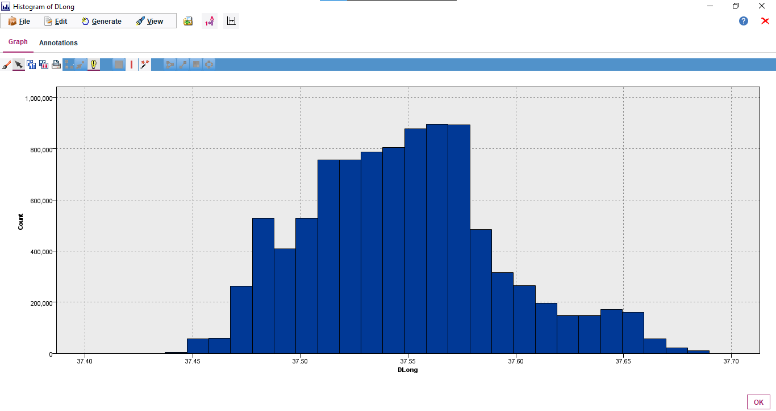

It shows the counts of the Dlong within a particular Range.

**DLatd:**

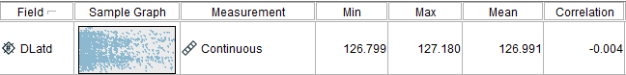



From the Output of this Audit Node, we can infer that:

* + 1. Values range from has 126.799 – 127.180
    2. It has the skewness = -0.007
    3. Mean = 126.991
    4. Standard Deviation = 0.083 shows that the data is distributed within the range of +- 0.083 from the Mean
    5. It has 9601139 Valid Values

**Graph for DLatd:**

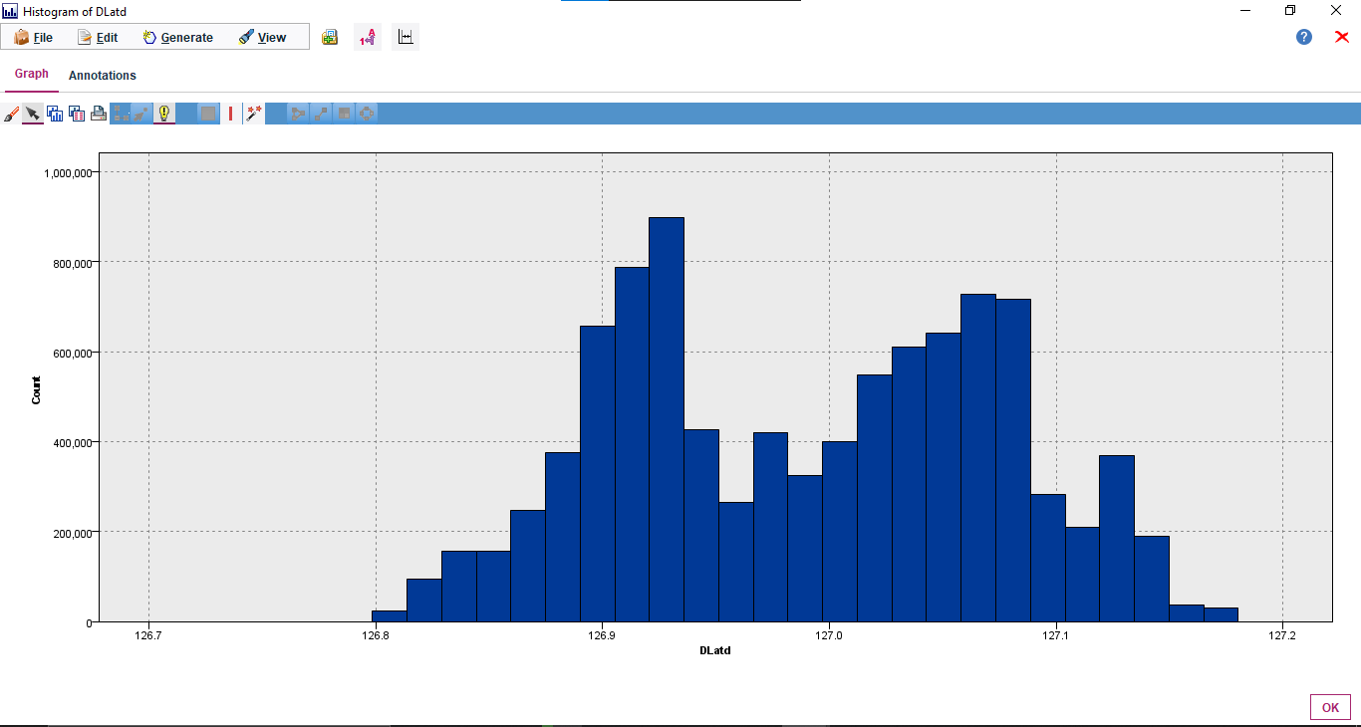

It shows the counts of the DLatd within a particular Range.

**Haversine:**

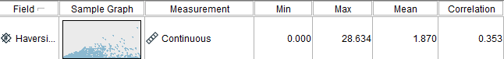

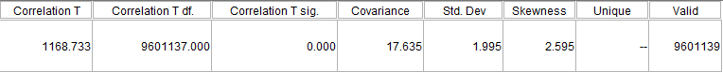

From the Output of this Audit Node, we can infer that:

* + 1. Values range from has 0.000– 28.634
    2. It has the skewness = 2.595
    3. Mean = 1.870
    4. Standard Deviation = 1.995 shows that the data is distributed within the range of +- 1.995 from the Mean
    5. It has 9601139 Valid Values

**Graph for Haversine:**

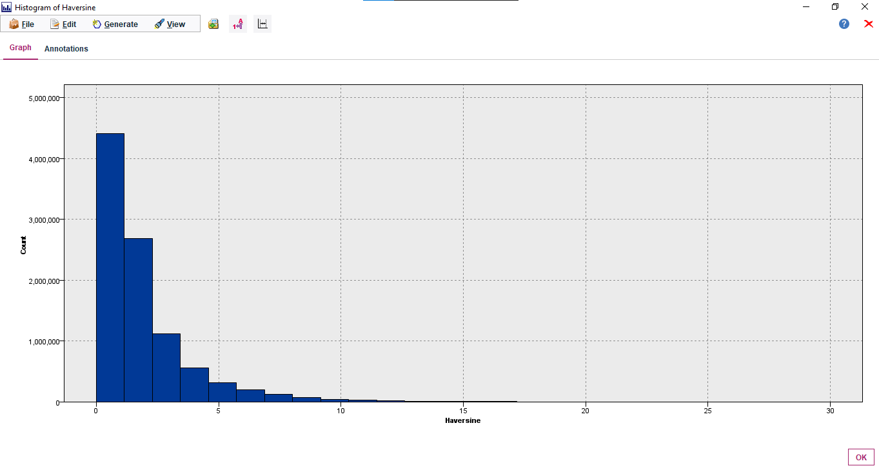

It shows the counts of the Haversine within a particular Range.

**PMonth:**

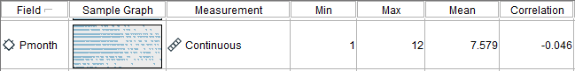



From the Output of this Audit Node, we can infer that:

* + 1. Values range from has 1-12
    2. It has the skewness = -0.332
    3. Mean = 7.579
    4. Standard Deviation = 2.697 shows that the data is distributed within the range of +- 2.697 from the Mean
    5. It has 9601139 Valid Values

**Graph for PMonth:**

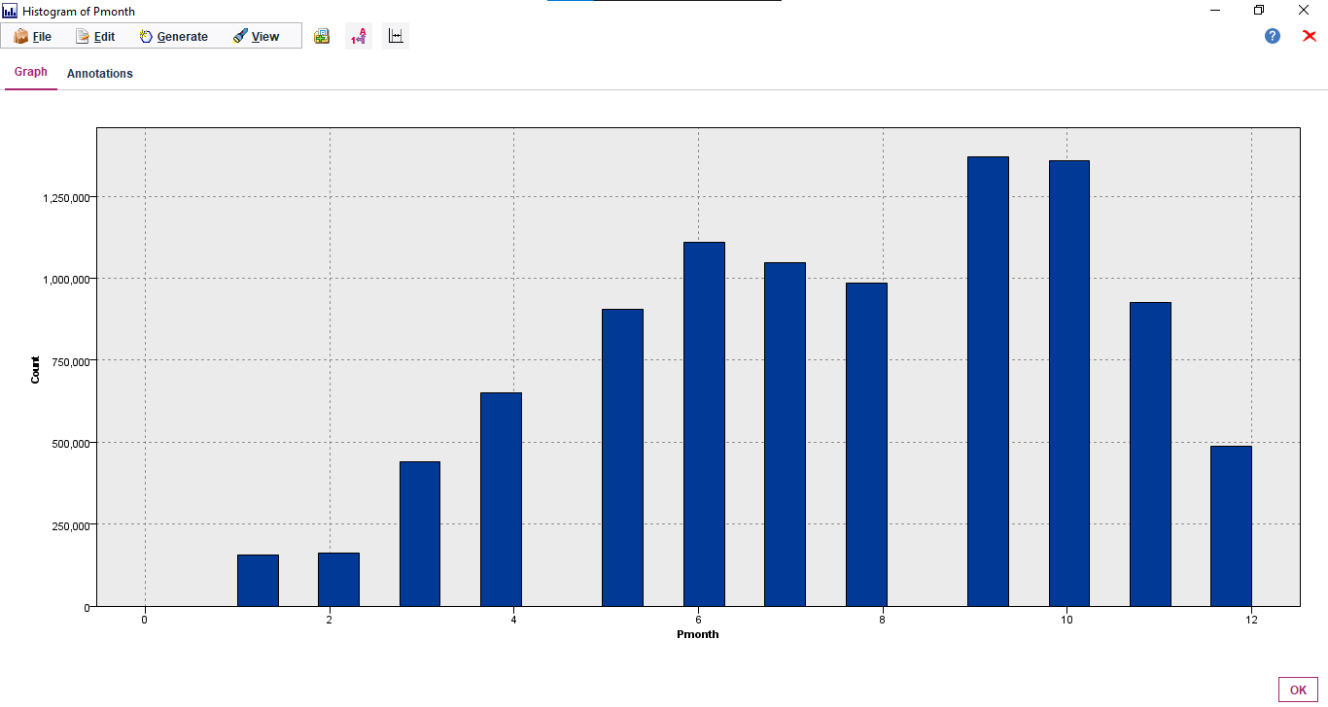

It shows the counts of the PMonth within a particular Range.

**PDay:**

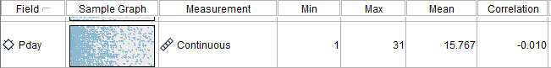

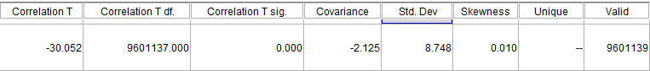

From the Output of this Audit Node, we can infer that:

* + 1. Values range from has 1-31
    2. It has the skewness = 0.010
    3. Mean = 15.767
    4. Standard Deviation = 8.748 shows that the data is distributed within the range of +- 8.748 from the Mean
    5. It has 9601139 Valid Values

**Graph for Pday:**

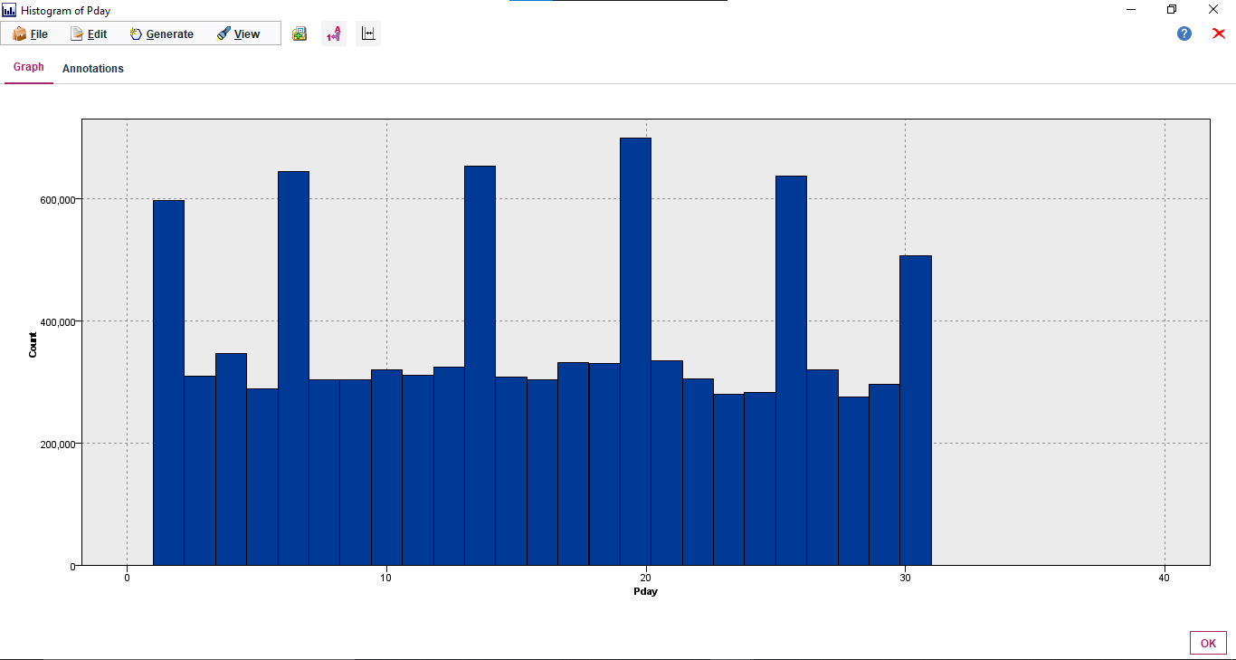

It shows the counts of the PDay within a particular Range.

**Phour:**

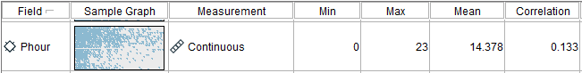

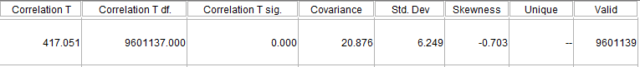

From the Output of this Audit Node, we can infer that:

* + 1. Values range from has 0-23
    2. It has the skewness = -0.703
    3. Mean = 14.378
    4. Standard Deviation = 6.249 shows that the data is distributed within the range of +- 6.249 from the Mean
    5. It has 9601139 Valid Values

**Graph for PHour:**

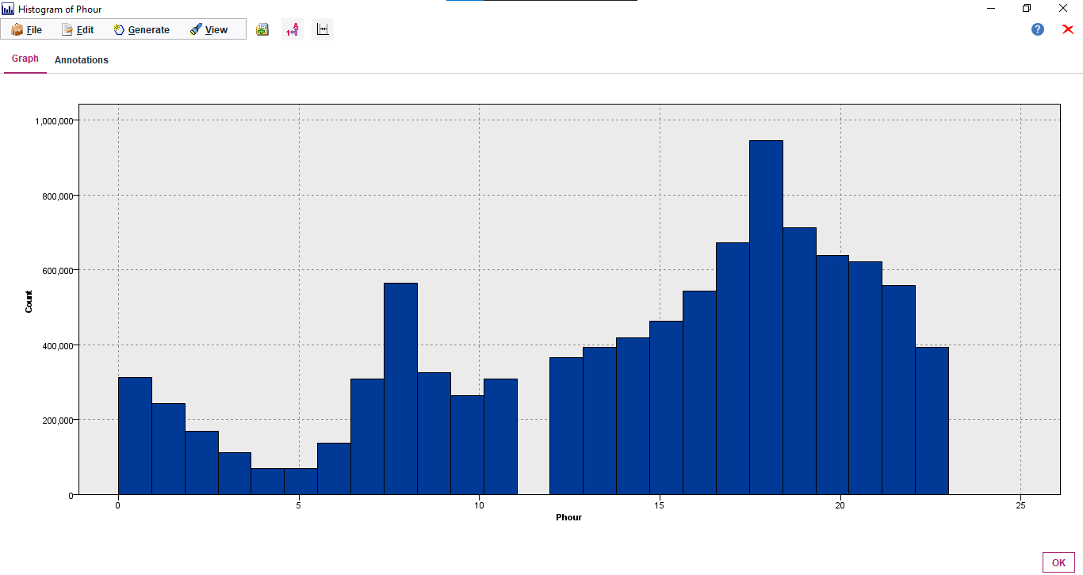

It shows the counts of the PHour within a particular Range.

**Pmin:**

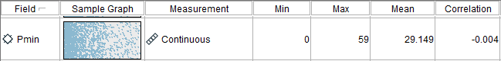

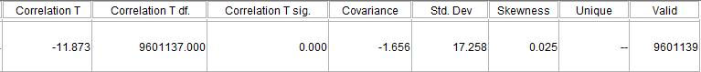

From the Output of this Audit Node, we can infer that:

* + 1. Values range from has 0-59
    2. It has the skewness = 0.025
    3. Mean = 29.149
    4. Standard Deviation = 17.258 shows that the data is distributed within the range of +- 17.258 from the Mean
    5. It has 9601139 Valid Values

**Graph for PMin:**

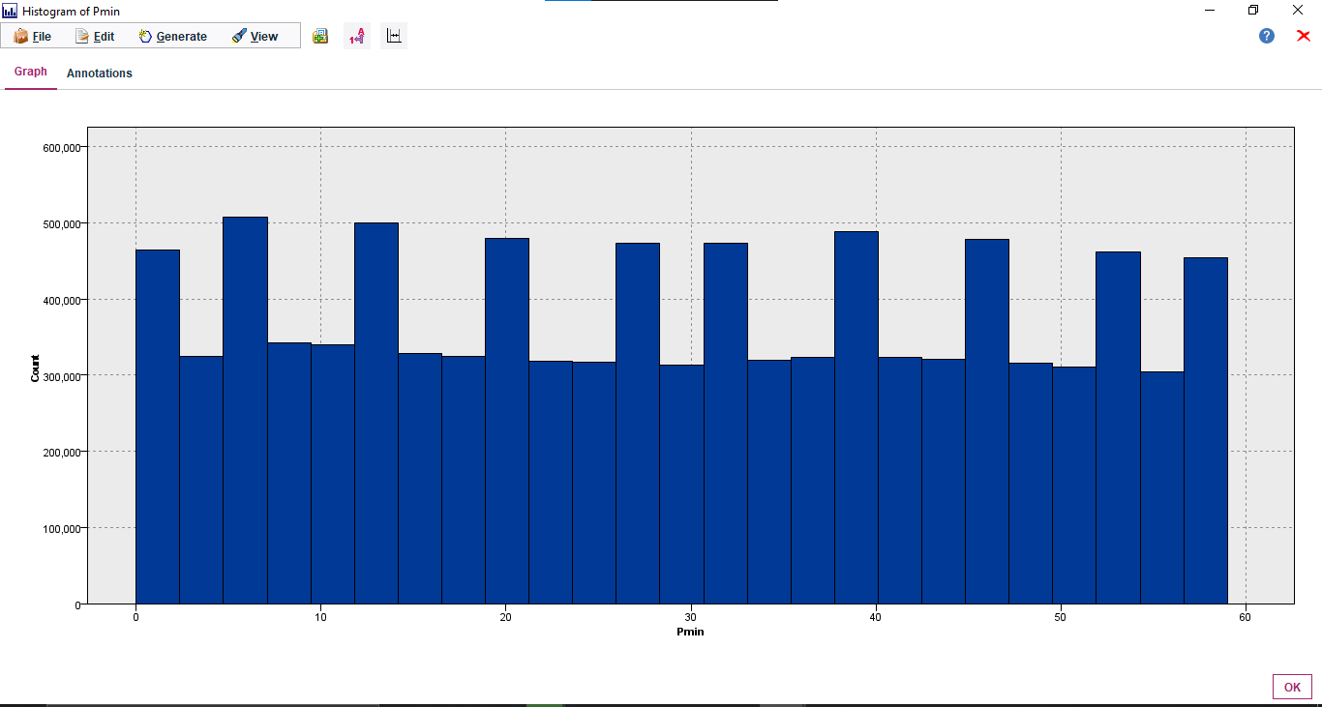

It shows the counts of the PMin within a particular Range.

**PDweek:**

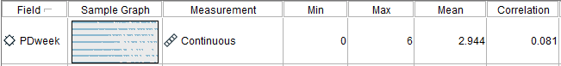



From the Output of this Audit Node, we can infer that:

* + 1. Values range from has 0-6
    2. It has the skewness = 0.029
    3. Mean = 2.944
    4. Standard Deviation = 1.976 shows that the data is distributed within the range of +- 1.976 from the Mean
    5. It has 9601139 Valid Values

**Graph for PDweek:**

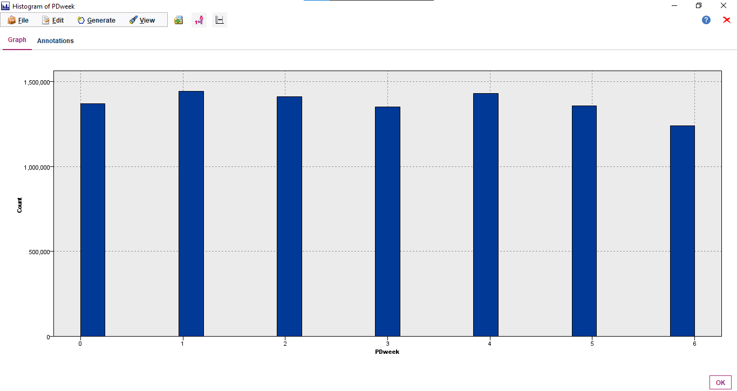

It shows the counts of the PDweek within a particular Range.

**Dmonth:**

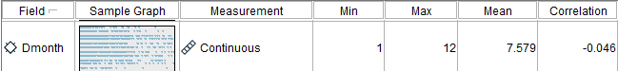

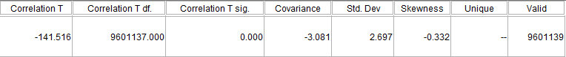

From the Output of this Audit Node, we can infer that:

* + 1. Values range from has 1-12
    2. It has the skewness = -0.332
    3. Mean = 7.579
    4. Standard Deviation = 2.697 shows that the data is distributed within the range of +- 2.697 from the Mean
    5. It has 9601139 Valid Values

**Graph for DMonth:**

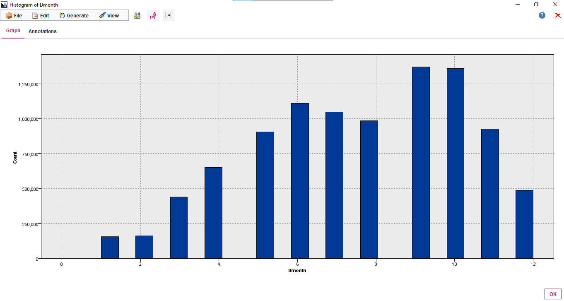

It shows the counts of the DMonth within a particular Range.

**DDay:**



From the Output of this Audit Node, we can infer that:

* + 1. Values range from has 1-31
    2. It has the skewness = 0.010
    3. Mean = 15.767
    4. Standard Deviation = 8.748 shows that the data is distributed within the range of +- 8.748 from the Mean
    5. It has 9601139 Valid Values

**Graph for DDay:**

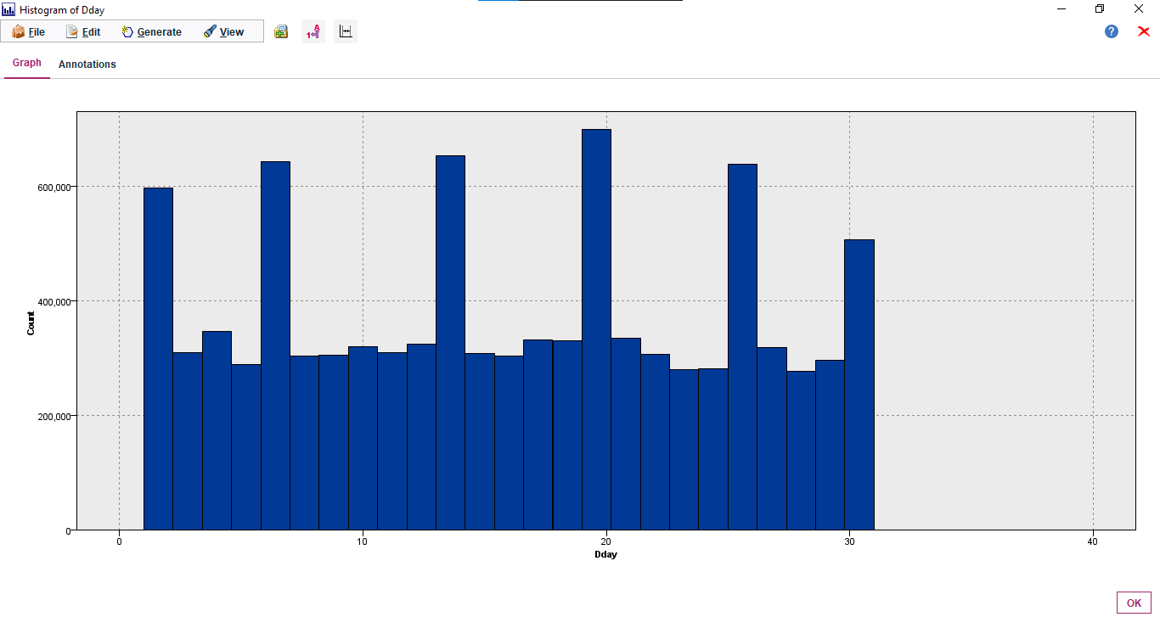

It shows the counts of the DDay within a particular Range.

**DHour:**



From the Output of this Audit Node, we can infer that:

* + 1. Values range from has 0-23
    2. It has the skewness = -0.708
    3. Mean = 14.426
    4. Standard Deviation = 6.484 shows that the data is distributed within the range of +- 6.484 from the Mean
    5. It has 9601139 Valid Values

**Graph for DHour:**

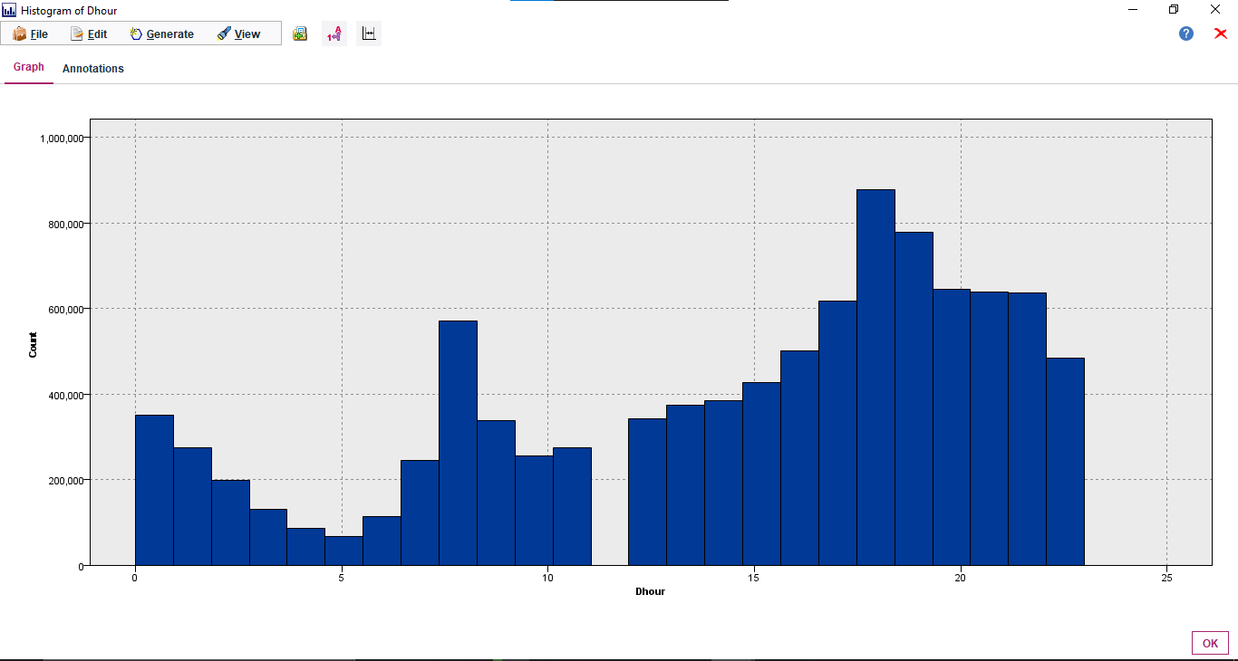

It shows the counts of the DHour within a particular Range.

**DMin:**



From the Output of this Audit Node, we can infer that:

* + 1. Values range from has 0-59
    2. It has the skewness = -0.036
    3. Mean = 29.993
    4. Standard Deviation = 17.310 shows that the data is distributed within the range of +- 17.310 from the Mean
    5. It has 9601139 Valid Values

**Graph for DMin:**

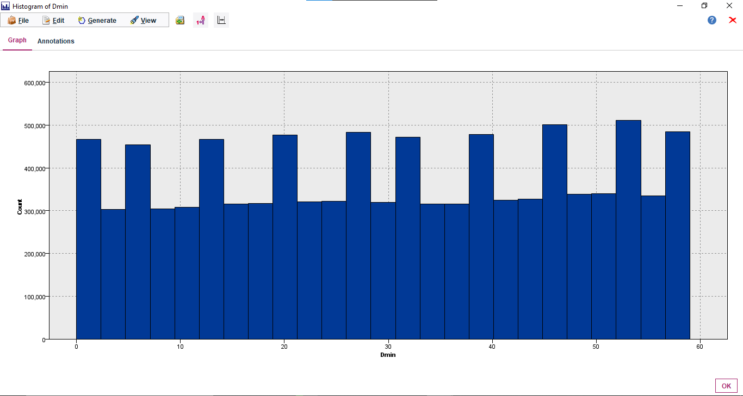

It shows the counts of the DMin within a particular Range.

**DDweek:**



From the Output of this Audit Node, we can infer that:

* + 1. Values range from has 0-6
    2. It has the skewness = 0.030
    3. Mean = 2.946
    4. Standard Deviation = 1.978 shows that the data is distributed within the range of +- 1.978 from the Mean
    5. It has 9601139 Valid Values

**Graph for DDweek:**

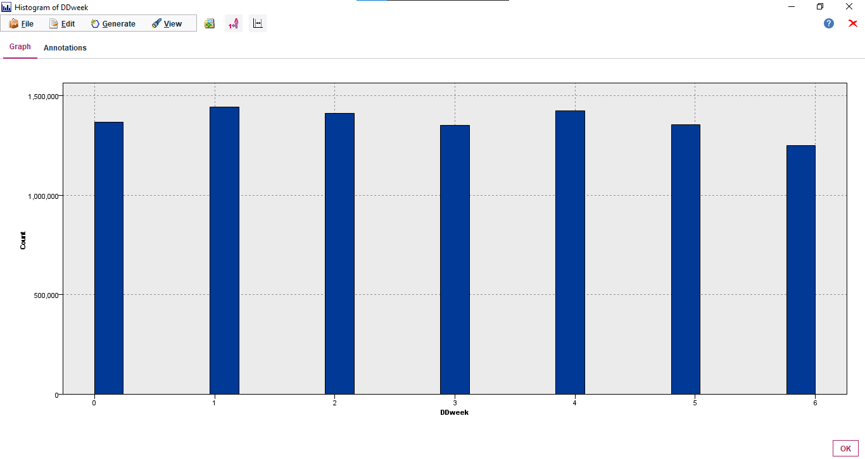

It shows the counts of the DDweek within a particular Range.

**Temp:**



From the Output of this Audit Node, we can infer that:

* + 1. Values range from has -17.800- 39.400
    2. It has the skewness = -0.618
    3. Mean = 18.562
    4. Standard Deviation = 9.498 shows that the data is distributed within the range of +- 9.498 from the Mean
    5. It has 9601139 Valid Values

**Graph for Temp:**

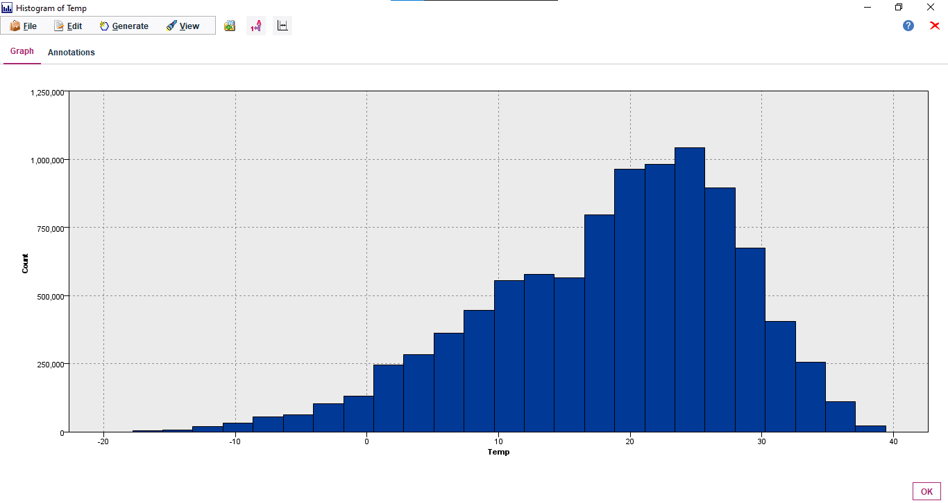

It shows the counts of the Temp within a particular Range.

**Precip:**



From the Output of this Audit Node, we can infer that:

* + 1. Values range from has 0-35
    2. It has the skewness = 48.858
    3. Mean = 0.018
    4. Standard Deviation = 0.374 shows that the data is distributed within the range of +- 0.374 from the Mean
    5. It has 9601139 Valid Values

**Graph for Precip:**

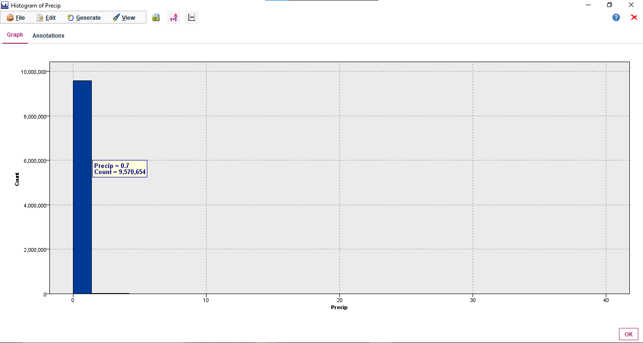

It shows the counts of the Precip within a particular Range.

**Wind:**



From the Output of this Audit Node, we can infer that:

* + 1. Values range from has 0.0- 7.400
    2. It has the skewness = 0.725
    3. Mean = 1.819
    4. Standard Deviation = 0.971 shows that the data is distributed within the range of +- 0.971 from the Mean
    5. It has 9601139 Valid Values

**Graph for Wind:**

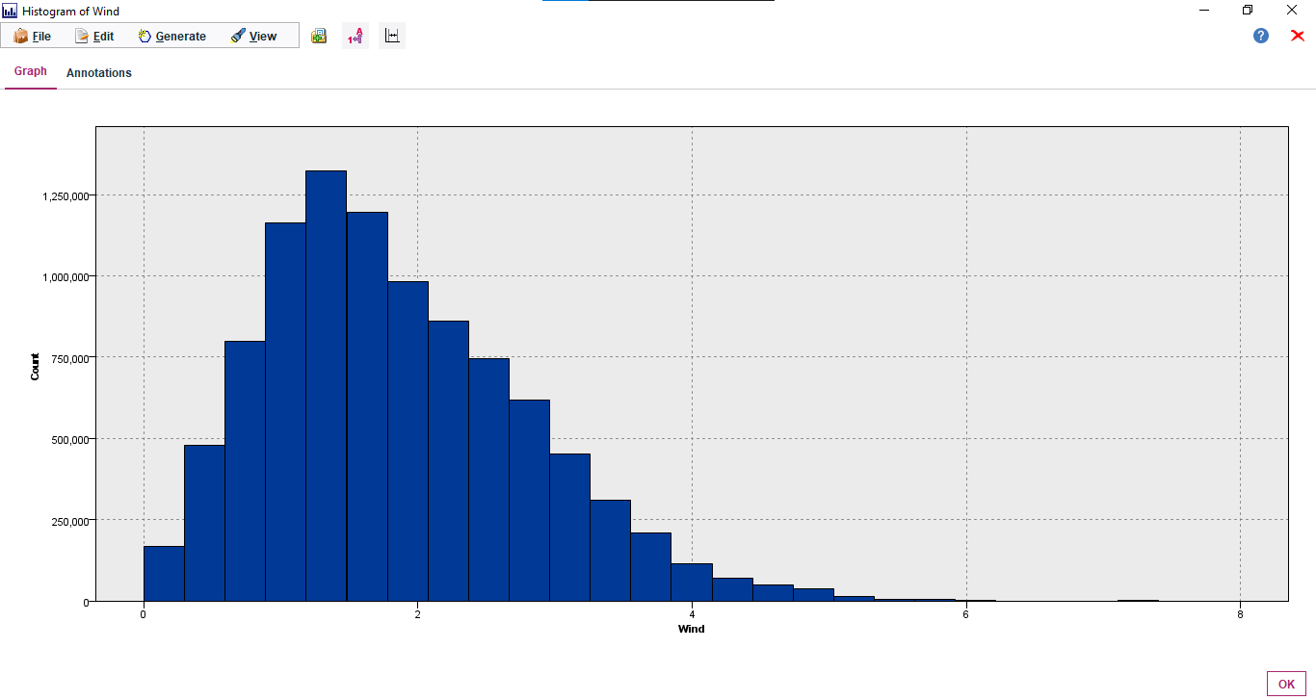

It shows the counts of the Wind within a particular Range.

**Humid:**



From the Output of this Audit Node, we can infer that:

* + 1. Values range from has 10.000- 98.000
    2. It has the skewness = 0.140
    3. Mean = 53.976
    4. Standard Deviation = 17.422 shows that the data is distributed within the range of +- 17.422 from the Mean
    5. It has 9601139 Valid Values

**Graph for Humid:**

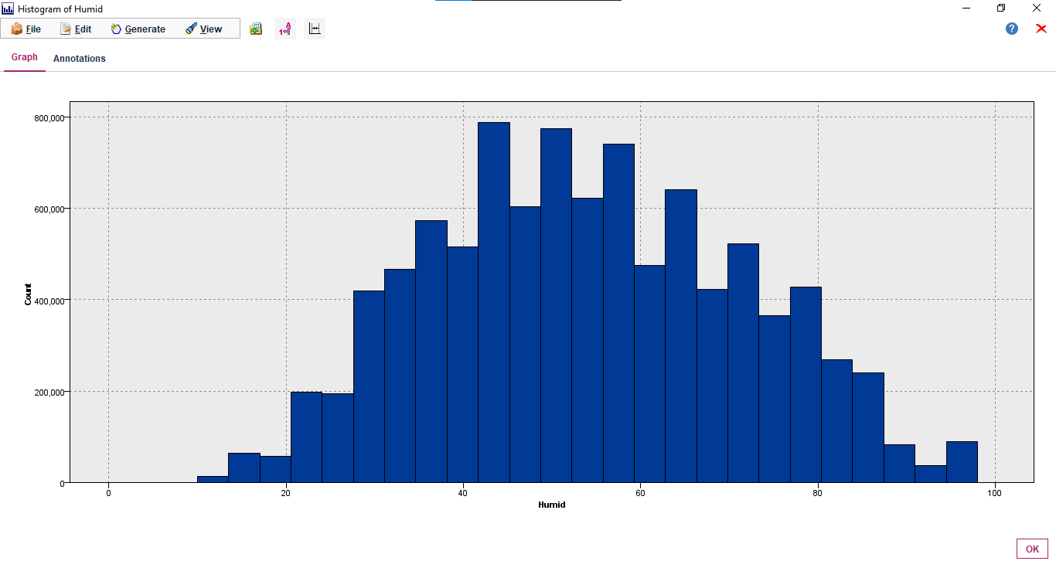

It shows the counts of the Humid within a particular Range.

**Solar:**



From the Output of this Audit Node, we can infer that:

* + 1. Values range from has 0.000- 3.520
    2. It has the skewness = 1.132
    3. Mean = 0.730
    4. Standard Deviation = 0.918 shows that the data is distributed within the range of +- 0.918 from the Mean
    5. It has 9601139 Valid Values

**Graph for Solar:**

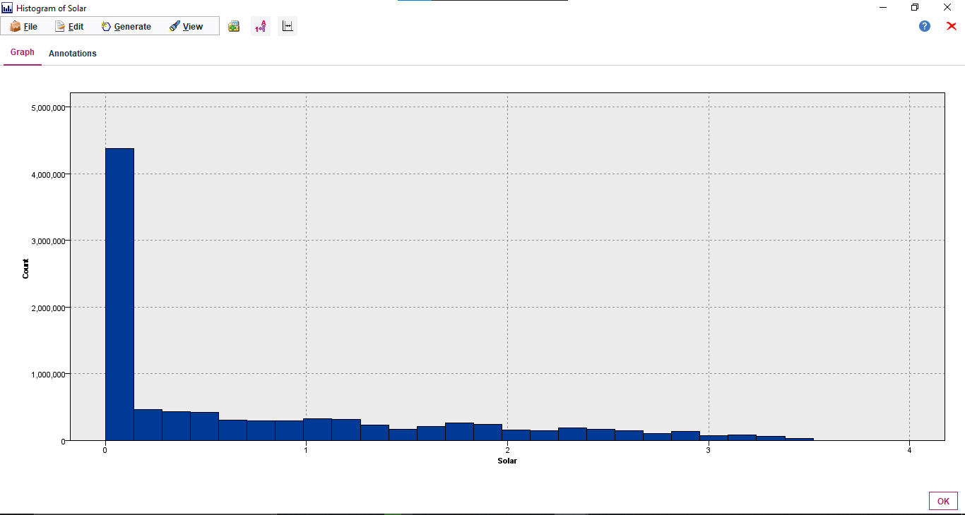

It shows the counts of the Solar within a particular Range.

**Snow:**



From the Output of this Audit Node, we can infer that:

* + 1. Values range from has 0.000- 8.800
    2. It has the skewness = 23.749
    3. Mean = 0.010
    4. Standard Deviation = 0.163 shows that the data is distributed within the range of +- 0.163 from the Mean
    5. It has 9601139 Valid Values

**Graph for Snow:**

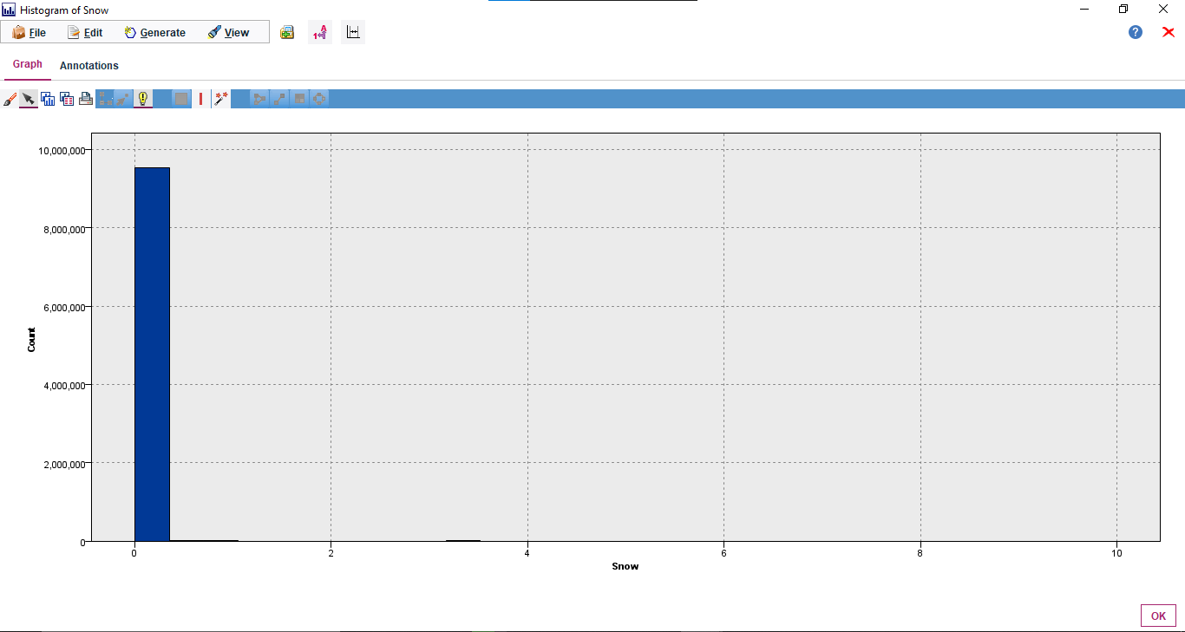

It shows the counts of the Snow within a particular Range.

**GroundTemp:**



From the Output of this Audit Node, we can infer that:

* + 1. Values range from has -13.600- 62.200
    2. It has the skewness = 0.182
    3. Mean = 20.724
    4. Standard Deviation = 12.652 shows that the data is distributed within the range of +- 12.652 from the Mean
    5. It has 9601139 Valid Values

**Graph for GroundTemp:**

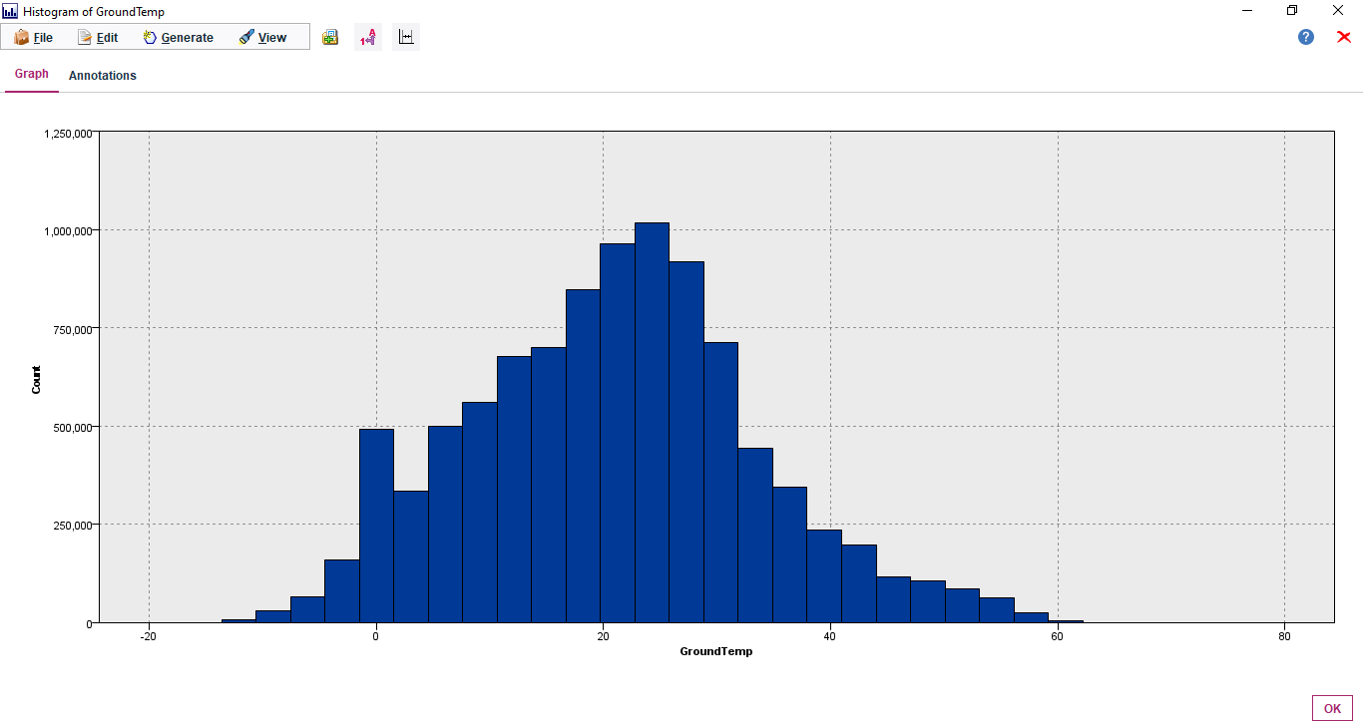

It shows the counts of the GroundTemp within a particular Range.

**Dust:**



From the Output of this Audit Node, we can infer that:

* + 1. Values range from has 0.000- 304.000
    2. It has the skewness = 1.919
    3. Mean = 32.458
    4. Standard Deviation = 24.073 shows that the data is distributed within the range of +- 24.073 from the Mean
    5. It has 9601139 Valid Values

**Graph for Dust:**

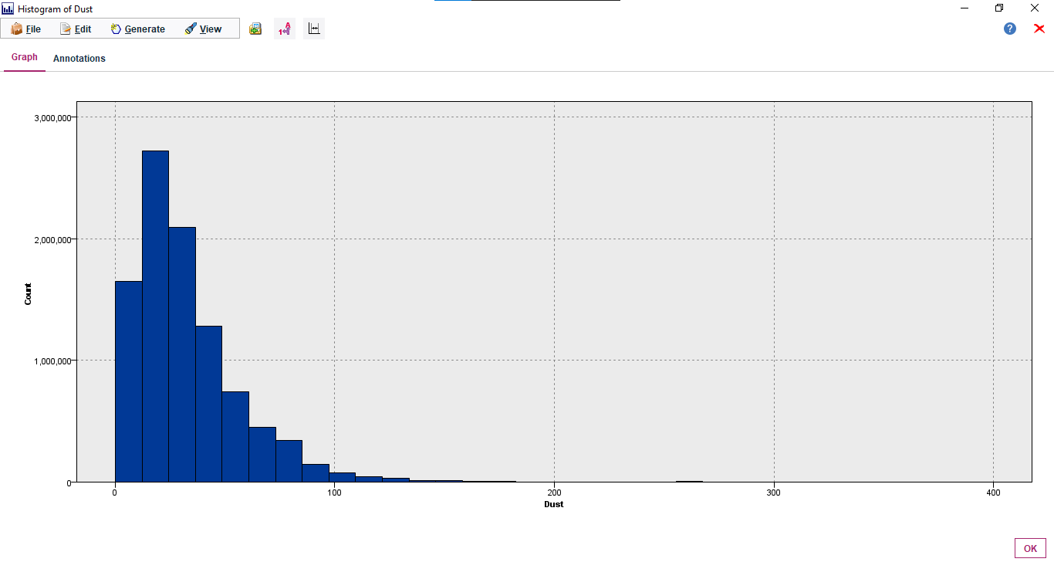

It shows the counts of the Dust within a particular Range.